**THE NKU-MAN USER GUIDE**

**Introduction**

The NKU-MAN (Namık Kemal University Morphometric Analysis) application focuses on watershed morphometric analysis within the scope of continent, country, province and district borders.

Meric river basin was used as an example study area in this step by step tutorial. The Meric (Maritsa, Evros) is the largest river on the Balkan Peninsula and it originates in the Rila Mountains in western Bulgaria and marks the border between Turkey and Greece. It flows east-southeast between the Balkans and the Rhodopes, past Plovdiv and Dimitrovgrad to Edirne in Turkey, and flows into the sea in Turkey is a transboundary water.

In this tutorial, execution steps are in bold and italic.

**Running the NKU-MAN application**

The NKU-MAN application used in this tutorial can be accessed through this link <https://mynet34.users.earthengine.app/view/nku-man>.

***STEP 1- Open your web browser and paste the link below in the address bar or simply hold down the Ctrl key on the keyboard and click the link. “***<https://mynet34.users.earthengine.app/view/nku-man>“***,***

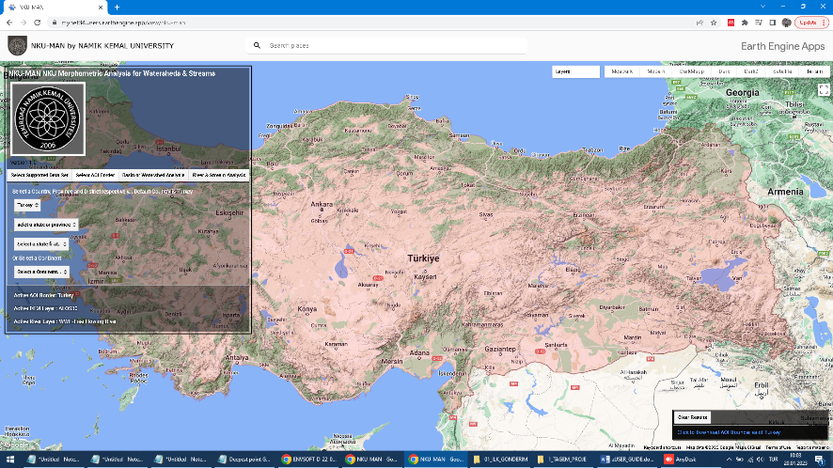

**Figure 1.** GUI of application

When NKU-MAN began running, the border of the default country was initialised, displayed, and centered on the map.

The NKU-MAN consist of a main panel and a result panel. There are, four essential tabs in the main panel, “Select Supported Data set”, “Select AOI Border”, “Basin or Watershed Analysis”, “River and Stream Analysis” (Figure 2, a,b,c,d). By default, Select AOI Border tab in the main panel is activated.

|  |  |
| --- | --- |
| a | b |
| c | d |

**Figure 2.** Application tabs, a) Select supported data set, b) Select AOI border , c) Basin or watershed analysis , d) River and stream analysis

**Selecting the AOI Border**

The default area of interest (AOI) boundary setting of NKU-MAN is Turkey.

***STEP 2- In Select AOI Border Tab, leave country as Turkey, than select the province of Tekirdağ where Namık Kemal University is located from below select box(Figure 3):***

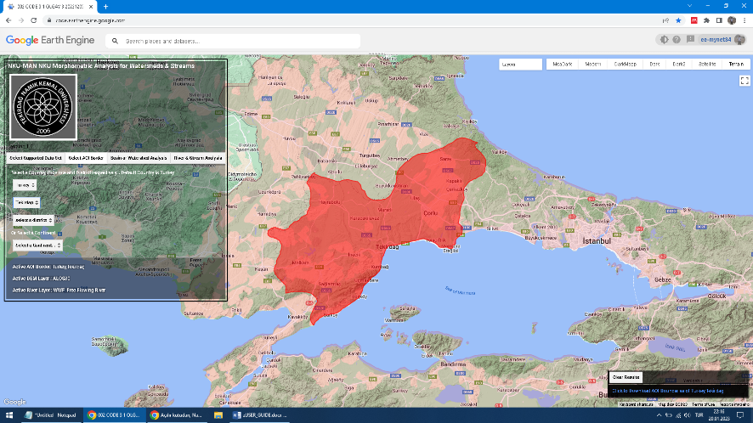

**Figure 3.** Selecting AOI

When an AOI is selected, AOI is centered in the map. You can download the generated AOI from result panel.

If the user wants to examine another continent, country, province or dicsrict, there are selection boxes for selecting continental borders, countries, provinces, or counties. The user must select the country, province and district, respectively.

**Selecting Basin or Watershed Boundary**

When an AOI is selected, then the user can select a basin or catchment dataset from “Select Basin or Catchment Area” tab. There are select boxes for data set options in “Select Basin or Catchment Area” tab.

***STEP 3- Click on Basin or watershed analysis tab(Figure 4)***

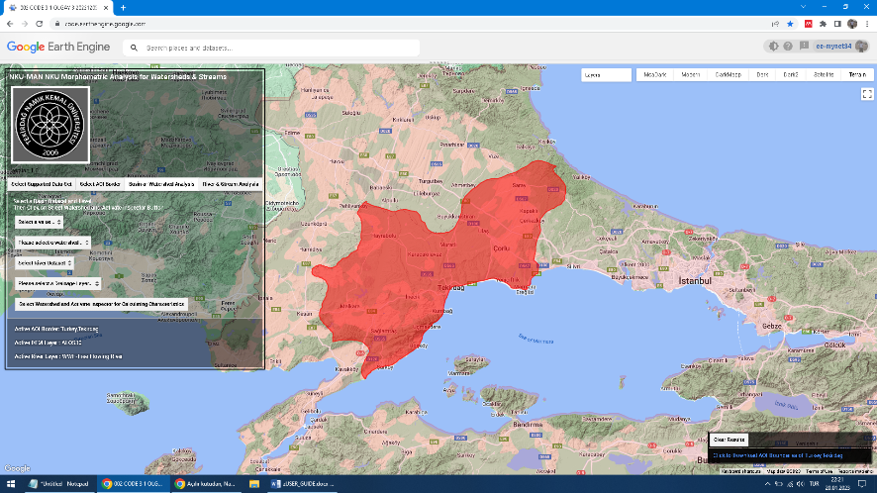

**Figure 4.** Basin or watershed analysis tab

“Basin or Watershed Analysis” tab is used for watershed analysis. The default settings for watershed dataset is” WWF HYDROSHEDS”

***STEP 4- Select “WWF HYDROSHEDS” for watershed data set select box(Figure 5):***

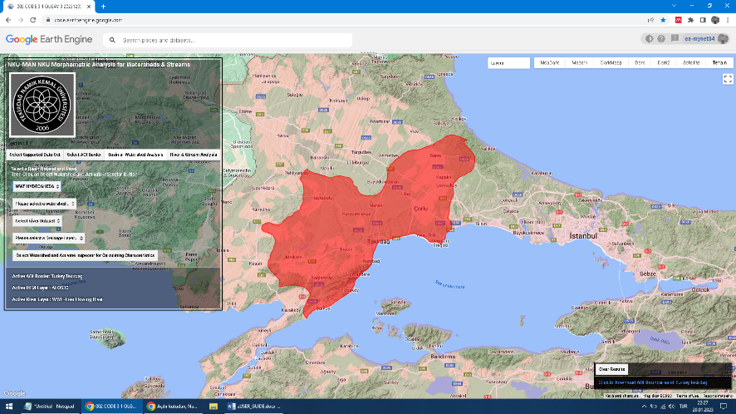

**Figure 5.** Selecting Basin Dataset

***STEP 6- Select “Level 5” from watershed data set level select box(Figure 6):***

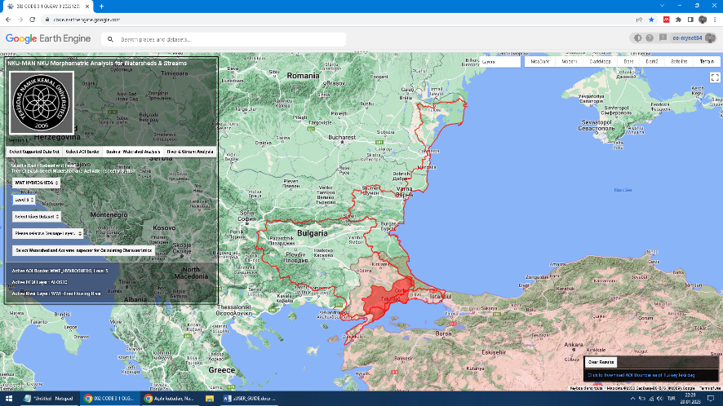

**Figure 6.** Selecting Basin dataset level

***STEP 7- Select “HydroRIVER V1.0” from select river data set select box(Figure 7):***

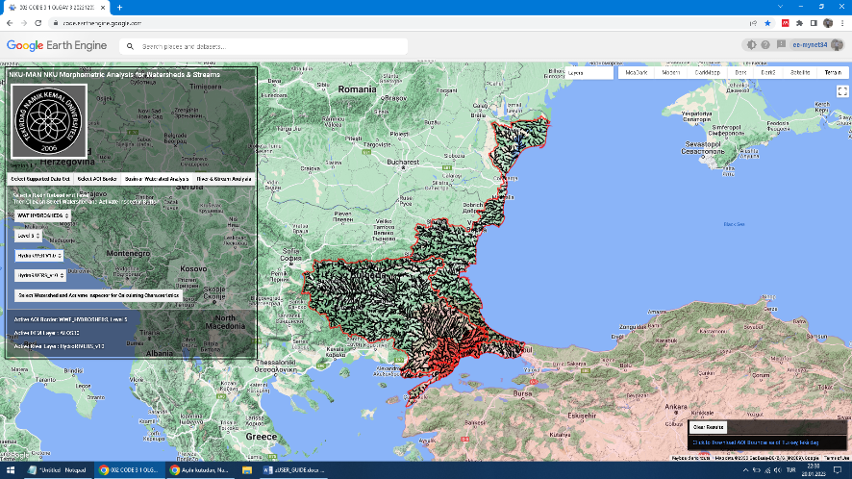

**Figure 7.** Selecting River Dataset

There are three basins covering the borders of Tekirdağ province and the default river dataset are displayed on the map (Figure 5a,b).

**Calculating Watershed Geometric, Watershed Relief, and Watershed Linear Characteristics**

***STEP 8- Click on the Select Watershed and Activate inspector Button, and than select Meric Basin from the map by clicking on it(Figure 8).***

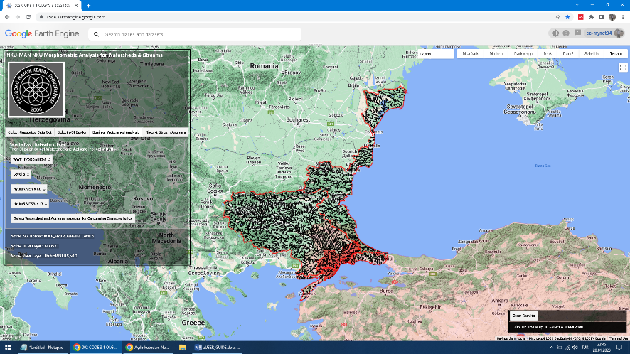

**Figure 8.** Selecting Watershed

After choosing a watershed dataset, watershed dataset level, river dataset and river data respectively, when the user clicks on the button labeled “Select Watershed and Activate Inspector”, the result panel at the bottom right of the window is activated, and the result panel displays Administrative Units Information, Watershed Geometric Characteristics, Watershed Relief Characteristics, Watershed Linear Parameters tables and download links for generated Watershed Geometric Parameters, Relief Characteristics tables and Watershed Boundaries, Download River Streams vector datas as kml(Figure 9).

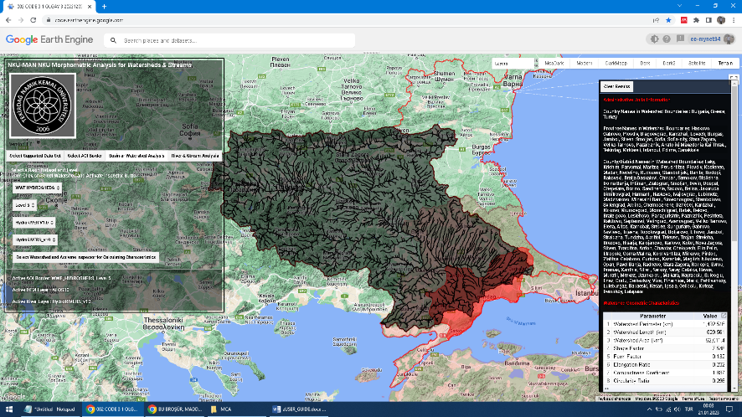

**Figure 9.** Displaying result of watershed characteristics

The user can change the watershed datasets from global data sets to local dataset. Then, below selected box gets local watershed levels~~.~~

***STEP 9- Click on the River & Stream Analysis tab (Figure 10)***

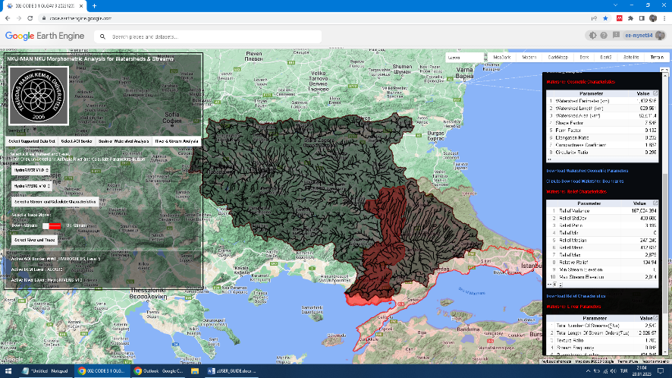

**Figure 10.** Selecting River & Stream Analysis tab

The “River and Stream Analysis” tab is for setting drainage texture and drainage network analysis parameters. When the user clicks on the” River and Stream Analysis” tab, the user can select global or local river datasets from select boxes. Displayed default map is the global WWF Free Flowing River Dataset. In order to calculate the drainage texture and drainage network characteristics, the River Dataset and the stream level must be selected, then the “Select a Stream and Calculate characteristics” button must be pressed (Figure 5a).

**Calculating Watershed Drainage Texture and Drainage Network Characteristics**

***STEP 10- Click on the “Select a Stream and Calculate Characteristics” button and click on a segment of stream on the map (Figure 11)***



**Figure 11.** Selecting a Stream and Calculating Characteristics

When the user clicks on any river segment on the map, NKU-MAN finds the nearest stream segment, and the drainage texture and drainage network characteristics are displayed as tables in the result panel. The selected segment is shown in red and streams in blue on the map (Figure 12).

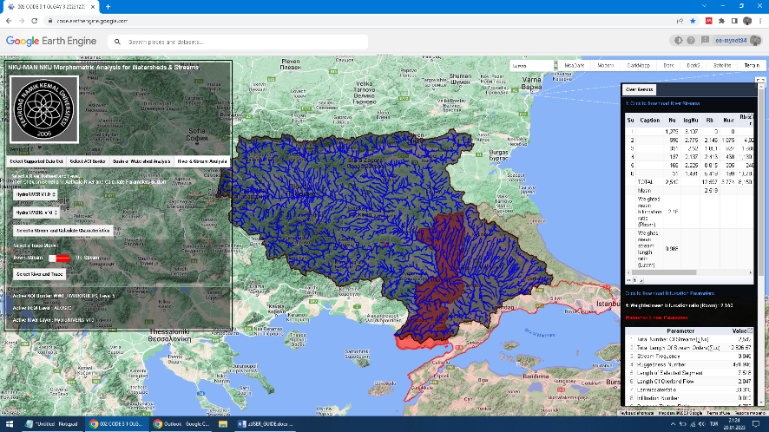

**Figure 12.** Displaying result of stream characteristics

For river data sets that have **Strahler Order** id field, the results panel gives drainage network and stream length characteristics. The results include the bifurcation ratio, weighted bifurcation ratios, and bifurcation ratio obtained from the Horton Diagram (Figure 6) including lengths, length ratio, and numbers for each stream order.

**Generating upstream and downstream monitoring functions.**

***STEP 11- Click on the Select a Stream and Trace, and than click on a segment of stream on the map***

When the user clicks on the “Select River and Trace” button, selecting any river or stream is possible. When the user clicks on the map, NKU-MAN finds the nearest stream segment and selects upstream or downstream of selected segment by down or up options. Default trace mode is the downstream mode. For example, when the user clicks on the red circle on the map The NKU-MAN displays downstream of selected segment on the map in blue (Figure 13). The results of downstream of the selected segment in red from the Meric river are shown in Figure 13. Selected segment displayed in red. In the result panel, an elevation profile graph is displayed. Also, number of streams towards downstream, sum of length of streams and length of selected segment is displayed in the result panel(Figure 13). With the help of the function in the application, the route of a segment of the Meric river to the point where it empties into the sea is shown. In addition, the elevation prophile graph along the route of the downstream to the point where it empties into the sea is shown in result panel.

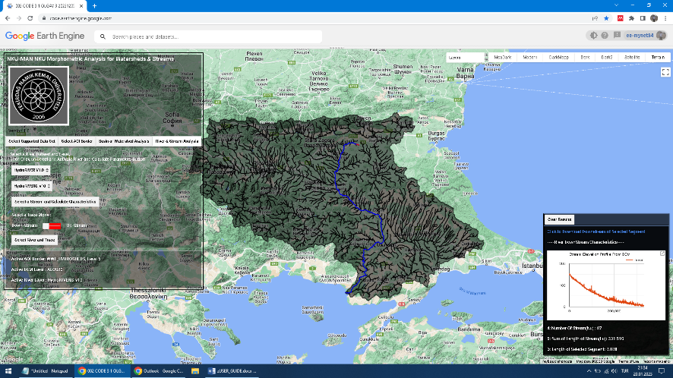

**Figure 13.** Displaying downstream and elevation graph of selected segment

***STEP 12- Click on a extreme point in the line on the elevation graph in the result panel (Figure 14)***

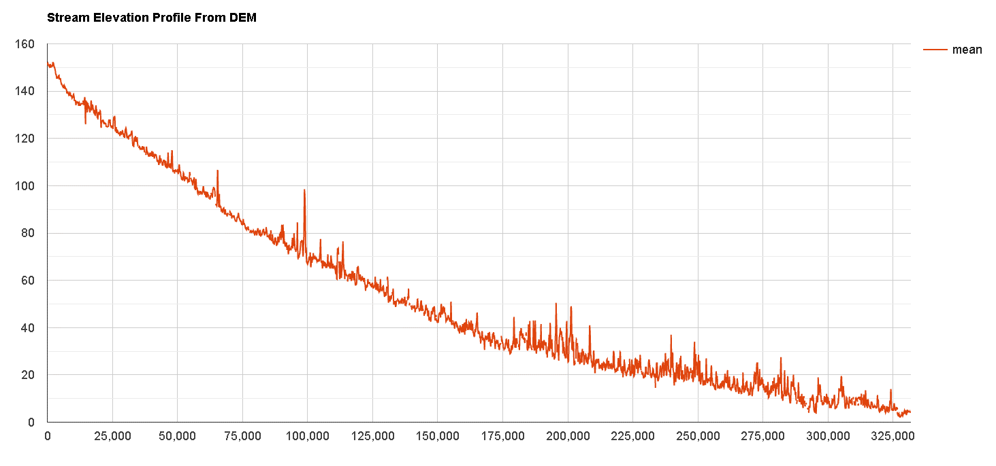

**Figure 14.** Clicking on extreme point in elevation graph

The river elevation profile graph is displayed, and this function can also be used to detect errors in streams vector data (Figure 14). The elevation profile graph shows unusual trends marked with a red circle.

The elevation graph in the result panel is user interacted and these points can be clicked on the graph to examine these segments of the river (Figure 15). When the user clicks on the red point in the graph in the red circle, map focused at associated segment, zoom and centered it on the map. The associated segment is in a red circle in the Figure 15

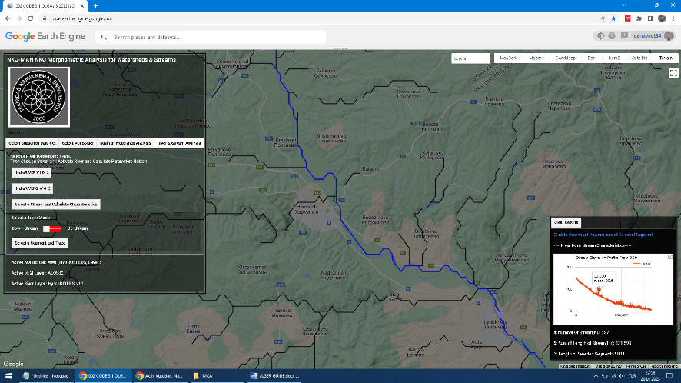

**Figure 15.** Displaying segment of which has extreme elevation value

***STEP 13- Click to Dark button to change map style on the map style bar (Figure 16)***

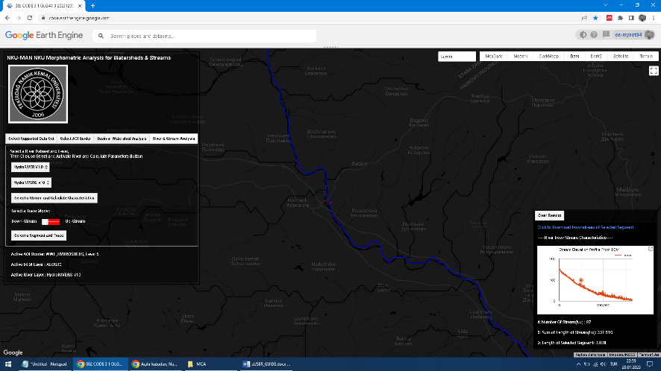

**Figure 16.** Displaying extreme elevation segment in dark map style

***STEP 14 - Click to Satellite button to change map style on the map style bar and zoom to the segment in red color(Figure 17)***

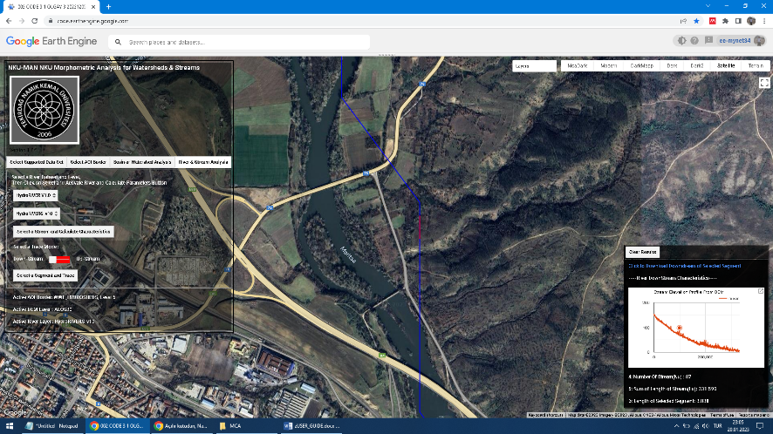

**Figure 17.** Displaying extreme elevation segment in satellite map style

It is observed that the elevation value is determined to be extreme because the river segment is faulty and passes over the land surface.

***STEP 15- Select slider switch below the Select a Trace Mode label, slide the button in slider switch to Up-Stream, click on the Select a Stream and Trace, and than click on a segment of stream on the map (Figure 18)***

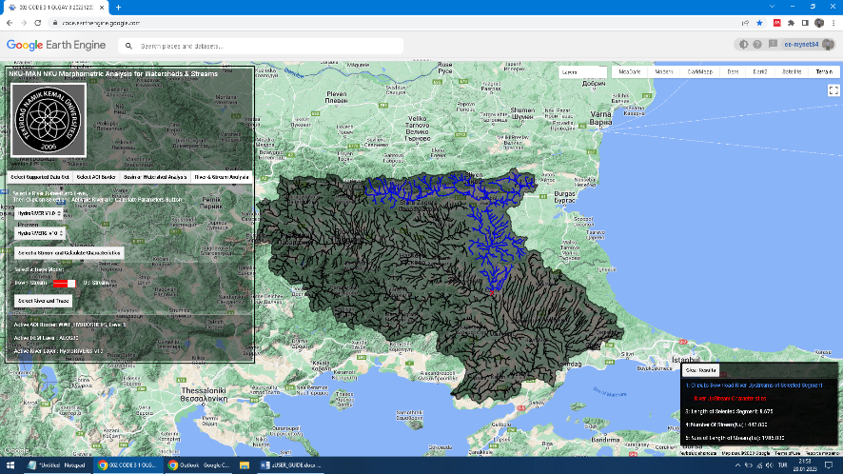

**Figure 18.** Displaying upstream of selected segment

When the user clicked on the map, NKU-MAN found the closest stream segment and selected upstream of the selected segment. For example, when the user clicks on the red circle on the map (Figure 18), all connected streams with selected segments were displayed. In the result panel, the number of streams towards all of the upstream, sum of the length of all upstream, and the length of the selected segment is displayed.

**Exporting results.**

The NKU-MAN has the ability to download generated AOI, watershed boundary, stream network, downstream and upstream network as KML files. The kml files can be opened in Google Earth or any GIS software compatible with KML format like ArcGIS.

For example, after STEP-2, AOI boundary, and after STEP-8, Watershed Boundaries, Download River Streams vector datas as kml.are generated as downloadable KML in the result panel.

Also after STEP-8, all of the generated watershed morphometric characteristics in tables can be downloaded as csv files, and graphs as CSV,SVG, PNG files.

The results of the exporting functions are shown in Figure 19. The exported KML files were opened and viewed in the Google Earth Pro as sample GIS software.

|  |  |
| --- | --- |
| a | b |
| c | d |

**Figure 19.** Exporting results as KML, a) watershed boundary, b)Watershed stream network, c) Downstream of selected segment, d) Upstream of selected segment

**Optional Properties of the NKU-MAN.**

In the “Select Supported Dataset” tab, there are three select boxes, for DEM, Flow Accumulation (ACC), and Flow Direction Datasets (DIR). There are check boxes for slope, aspect, isolines generated from DEM as map layers.